Assessing and Communicating Uncertainty

User Guide for

Monte Carlo Template

Document Version **v1**

Contents

1 Model Overview 3

1.1 Model Contents 3

1.2 Model Format 4

2 Running the Model 5

2.1 Process Flow 5

2.2 Data 5

2.3 Forecast Options 7

2.4 Full Trend Forecast 9

3 Outputs 10

3.1 Summary 10

3.2 Shadow 10

4 Phasing Calculators 12

4.1 Duration Profiles 13

4.1.1 Data 13

4.1.2 Duration Profile 14

Version Control

|  |  |  |  |  |
| --- | --- | --- | --- | --- |
| **Document Version** | **Version Date** | **Model Version** | **Author** | **Changes** |
| 1.0 | 19/7/2019 | 1.1 | Andrew Taylor | Initial version |

# Model Overview

The model was created to provide an example of how Monte Carlo analysis can be used to estimate the combined uncertainty from a number of distinct sources, taking into account the interactions between the factors.

Depending on the users needs the model may be sufficient, however in many instances the model may need to be adapted to take into account specific interactions or distribution. Information to help with this can be found in the technical guide.

Before using the model, consider whether Monte Carlo is the correct approach to use. It is useful for combining different uncertainties, but does not help understand them individually, and is highly dependent on the quality of assumptions feeding into it. For more information, see the communicating uncertainty material.

## Model Contents

|  |  |
| --- | --- |
| **Worksheet** | **Description** |
| Controls | To record information about the purpose of the analysis |
| Register | Contains input assumptions about the factors that drive variance in the analysis |
| Inputs | Contains parameters used in running the model |
| Calculations | Runs a single scenario based on the details in the register tab. |
| Current Run | Contains the outputs of the run, and any additional overlays that may be applied |
| Outputs | A full list of the results of each run |
| Model Output | A summary aggregating the results into an overall distribution. |

## Model Format

|  |
| --- |
| Input |
| Calculation |
| Output |

# Running the Model

## Updating the register

The first step in updating the model is to set how the various sources of uncertainty should be modelled. Each entry needs a likelihood, distribution, correlation through the years modelled and optionally information on how it iteracts with the other entries, details on these are covered below.

An idividual risk can be disabled by changing the value in the ‘Include?’ column to ‘N’.

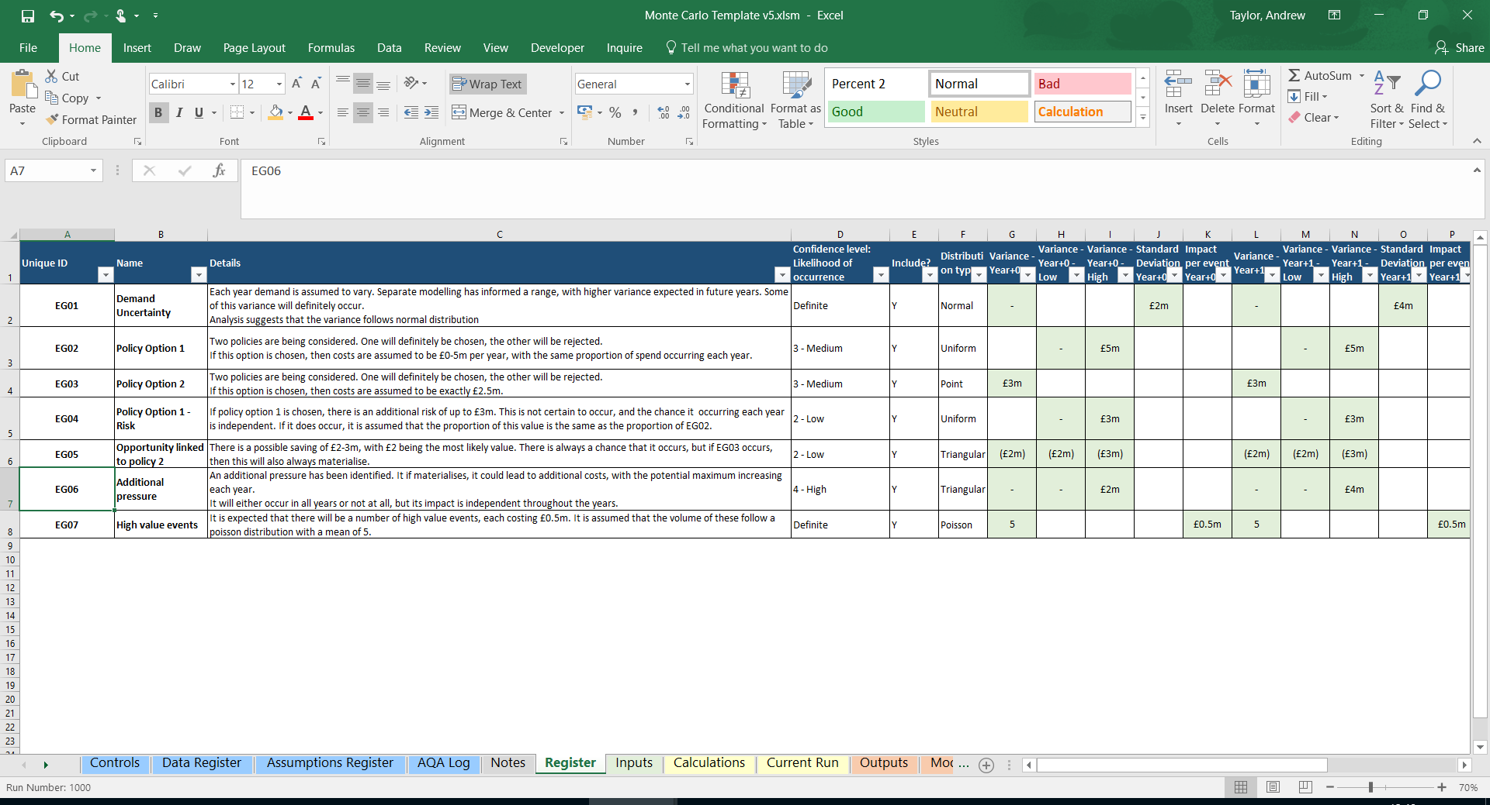

### Confidence level

This parameter defines how likely an event is to occur. This is set as a range as it is rare to be completely certain of the exact likelihood. This range can be seen and modified in the Inputs tab.



When running, the model picks a probability of occurrence from within this range before testing for occurrence.

### Distributions

This section must be modelled for an entry to be included. Different distributions take different information, the required fields for the selected distribution are highlighted.

**Uniform**

The model will pick a value between the stated minimum and maximum, with all values being equally likely.

**Triangular**

The model will pick a value between the stated minimum and maximum, but will weight it towards the specified central value.

**Point**

The model will simply return the central value.

**Normal**

This will be modelled as a normal distribution with the central value as the mean and the stated standard deviation.

**Poisson**

The model generates a Poisson distribution with a mean based on the central value. It also considers the value per occurrence, which can be used to set the impact that each occurrence has – when considering variance purely in volume terms this should be set to 1.

### Interaction with other entries – occurrence

Entries do not always occur in isolation. One materialising may prevent another or may make it more likely. The model can account for some of the potential interactions. Note that when entering relationships, you must start with an independent entry that other entries are checked against.

In the below, A represents the baseline entry and B represents the risk with the relationship specified.

**Exclusive**

B will occur if and only if A does not.

**Matches**

B will occur if and only if A does.

**Sufficient**

If A occurs, B will also. If A does not, then B may or may not occur depending on its likelihood.

**Prevented by**

If A occurs, B will not. If A does not, then B may or may not occur depending on its likelihood.

**Necessary**

If A does not occur, neither will B. If A does, B may or may not depending on its likelihood.

### Interaction with other entries – value

The value of the entries may also be dependent on other values. For example, A with the occurrence section, you must start with an independent entry that other entries are checked against,

In the below, A represents the baseline entry and B represents the risk with the relationship specified.

**Same proportion**

The same proportion of B occurs as in A.

### Interaction between years

By default, the model assumes that the impacts each year are independent. This is frequently not the case, often a materialised risk will occur in all years, and the values could be related. These relationships can be specified here.

**Same proportion**

If the entry occurs, it will occur in all years and the values will be the same proportion.

**Matches**

The risk will either occur in all years or not at all

**Stops after non-occurrence**

After the first instance of non-occurrence, the entry will not occur again – this may be useful in modelling an impact that is expected to drop out.

**Cumulative**

This is only defined for risks modelled under a uniform distribution. Here, if the risk occurs in a year it forms the new minimum for all years going forwards.

## Inputs

On the inputs tab, check that the likelihood ranges are correctly defined.

The number of runs should be set to a level appropriate to the number of entries being modelled, with more complex interactions needing more runs. To see if the current level if sufficient, run the model multiple times and ensure that the results remain stable.



Once the model has been set up properly, press run to run the model.

# Outputs

## Outputs

Overview

This model shows a complete list of the results of all runs



This tab contains the results of each run, and can be used in analysing the variance.

## Model Output

Overview

A summary of the results from the output tab

This model shows a complete list of the results of all runs

This tab contains a summary of the results, showing the range of potential outcomes under the input assumptions.

